At St Michaels Pre-school
• We are a free-flow pre-school and children have access to outside provision in all weathers, so with this in mind please ensure your children are dressed in appropriate clothing for the weather. We also enjoy lots of messy, exploration activities and water play.
Therefore, children still require waterproof trousers or puddle suits to wear outside even when warm and plenty of changes of clothes as the likely hood of getting wet and dirty is high, even without rain.



Essentials Kit checklist:
- A light weight puddle suit and pair of wellies, which can be left at pre-school, are a must.
- Hopefully the sun will therefore a sunhat is also essential and a lightweight raincoat as we all know British weather can be unpredictable.
- Please can you remember to apply suncream before dropping your child for their session. If your child is attending all day, we are happy to re-apply at lunchtime so please pop one in their bag, but remember to name it first. 11 Reasons Sunscreen Is Important for The Skin & How to Use It (stylecraze.com)
- A well-stocked bag with multiple changes of clothes including socks, t-shirts and jumpers as well as trousers and pants. Please remember a bag for wet/dirty clothes to be placed separate from their clean clothes after changing.
- Please remember to check and restock wipes and nappy sacks as well as nappies/pull ups daily.
- Naming all items is essential if you don’t want them to become lost. This includes hats, shoes, coats, bags, water bottles and lunchboxes.
Summer Term 1, April 2026
A big warm welcome back to all our parents and carers. Our newsletter is emailed at the start of every half term, we hope it is engaging as well as informative. What do you think? What information would you like to be included in future? Don’t forget to also join our Facebook page to see regular updates on activities your children engage in and enjoy.

Key dates for your diary

Monday 13th April- First day of term
Monday 4th May- Bank holiday closure
Wednesday 20th May-Games/garden party
Friday 22nd May- Last day of term
Monday 8th June- Parent consultations start
Wednesday 10th June- Leaver’s photo
Friday 19th June- Father’s Day breakfast
Friday 19th June- Parent consultations end
Saturday 27th June- Family fun day
Monday 20th July-Leaver’s trip
Sports!
We have chosen to focus on sports this half term as the winter Olympics have just finished and the Fifa world cup begins on 11th June 2026. We are excited to explore and try a range of different sports with the children and if you, the parents or other family members play or coach any sports we would love to welcome you in to talk about your experiences and maybe a little demonstration! If so, please do get in touch and arrange a visit with Naomi. Sharing real life experiences really does increase the children’s excitement and who knows might inspire their future career paths. If your children partake in any activities, we would love to see photos to spark discussions of their first-hand experiences.



- Gentle reminder: If your child is due to start school September 2026 you will receive an email on Thursday 16th April informing you of your child’s school allocation. If you didn’t apply online for your child’s school place then you will receive a letter in the post. Please can you let Naomi know, as soon as possible, which school your child has been allocated for September to enable us to begin transition plans.

Important Notice!
Events such as the teddy bears picnic and Family funday are held to raise much needed funds for our pre-school provisions. These events are run by the committee. The committee are essential to the general running of our pre-school and made up completely by volunteers. The more parents/Grandparents who step forward and offer vital support the more opportunities can be provided for your children. Currently the committee numbers are low and current members are likely to step down as their children finish their pre-school journey; therefore, new members are essential to continue running smoothly. Please contact either Naomi or Cameron at stmichaelscommittee@outlook.com to find out how you could help!

St Michaels Pre-school
Colebrook way, Andover, SP10 3BB
T: 07940 569651
St Michael's Pre-school – Encouraging independence, resilience and learning through play (stmichaelspreschool.co.uk)

1 | 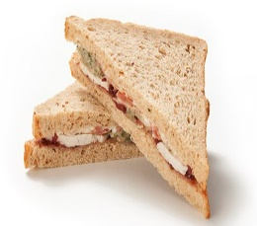 |  | 

 | 2 |  |  |  |  | 
 |  |  |  |  |  | Egg
 | 3 |  |  | 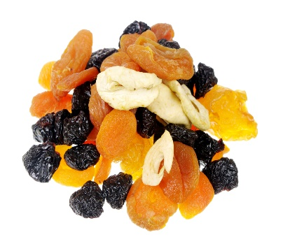 |  | 
 |  |  |  |  |  | Raw vegetables
 | 4 |  |  |  |  | 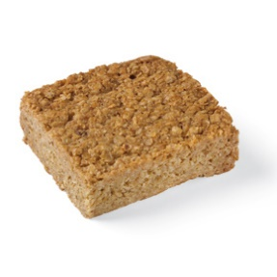
 |  |  |  |  | Small flapjack or cake

Reminder:
We are a healthy eating setting in line with Hampshire County Council’s schools. If your child is joining us for lunch, we do ask that the contents are healthy, nut free and of a suitable portion size for a pre-school child. These are a few suggestions, one item from each number is plenty and provides a healthy and balanced lunch for a typical 2–4-year-old.

Always include a refillable bottle of water and icepack as we are unable to store lunchboxes in the fridge.
Ensure the food is cold or able to remain warm and prepared in a way your child likes, i.e. crusts removed, slices instead of sticks. Grapes, olives and cocktail sausages must all be cut length ways to minimize risk of chocking.
All children are encouraged to eat everything in their lunchbox so please try not over-load and 1 treat item is plenty.

Important Notice!
We are a nut free setting. Please can you check items do not contain any form of nuts before placing in lunch boxes!

