

Key dates for your diary
Monday 23rd February- Pre-school re-opens
Friday 13th March- Mother’s Day breakfast
Saturday 22nd March- Teddy bear’s picnic
Friday 27th March last day of term
Wednesday 20th May- Garden party
Friday 19th June- Father’s Day breakfast
Saturday 27th June Family fun day
Monday 20th July-Leaver’s trip

Spring term 2 2026
Our newsletter is emailed at the start of every half term and provides you with Key dates for your diary, and essential information. Therefore, please remember to let us know if you are not receiving emails or you change yours. We hope you find the newsletter engaging as well as informative but do make sure to follow us on Facebook as we post regular updates and share activities.

Welcome and a big hello to Thomas who has recently joined us.

At St Michaels Pre-school
• We are a free-flow pre-school and children have access to outside provision in all weathers so with this in mind please ensure your children are dressed in appropriate clothing for the weather and always bring a coat to pre-school. We also enjoy lots of messy, exploration activities and water play.



Essentials Kit checklist:
- The weather is likely to remain cold for a while yet so please layer children up and a jumper/cardigan is a must.
- A warm puddle suit and pair of wellies, which can be left at pre-school, and remember a change of shoes as wellies often get wet. A coat is essential for children to access outside provision.
- Please remember to check your child’s bag daily and restock with multiple changes of clothes including socks, t-shirts and jumpers as well as trousers and pants. Please remember a separate bag for wet/dirty clothes to be placed away from their clean clothes after changing.
- Please remember to check and restock wipes and nappy sacks as well as nappies/pull ups daily.
- Naming all items is essential if you don’t want them to become lost. This includes shoes, coats, bags, water bottles and lunchboxes.



This term we are focusing on food!
We have many exciting activities planned for this half-term around growing and discussions on where food comes from as well as our likes and dislikes.
A plea!
The children really enjoyed our visit to the shop and selecting new foods to try. We would like to extend on from this and would be very grateful if your child could bring in some of their favorite foods to share with their peers. NB: it must be prepped and ready to eat.

Lastly, Wednesday 4th February @19.30, we held our re-scheduled annual general meeting (AGM)
Our pre-school is a charity run pre-school that requires a committee of volunteers including parents to keep the pre-school running smoothly and help organize fundraise events to provide valuable opportunities for your children.
Without an active committee pre-school cannot operate to find out more information please contact either Naomi or Courtney stmichaelscommittee@outlook.com to find out how you could help!
We are still in need of someone to take over the Role of Chair, as Courtney Will be leaving at the end of April.
Without this position filled the preschool can not run

St Michaels Pre-school
Carpenter’s cottage, Newbury Road, Enham Alamein, SP11 6JS
T: 07940 569651
St Michael's Pre-school – Encouraging independence, resilience and learning through play (stmichaelspreschool.co.uk)
1 | 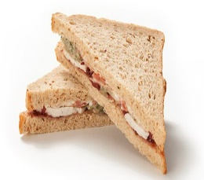 | 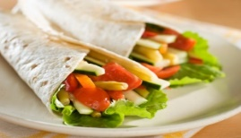 | 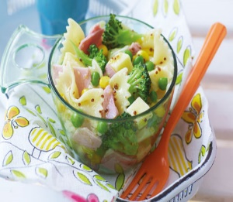

 | 2 | 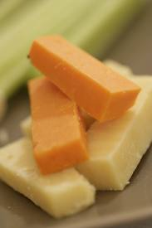 |  |  |  | 
 |  | Cheese |  | Yogurt |  | Egg
 | 3 |  |  | 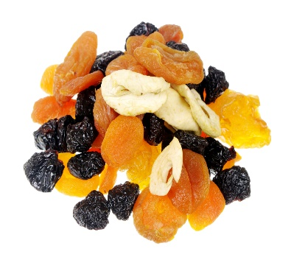 |  | 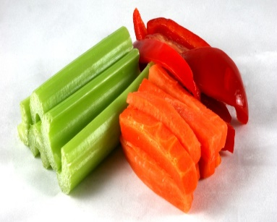
 |  | Fresh fruit |  | Dried Fruit |  | Raw vegetables
 | 4 |  |  | 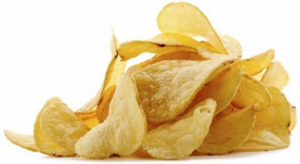 |  | 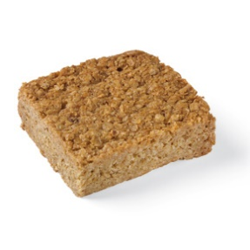
2x Biscuit |  |  | ½ packet crisps |  | Small flapjack or cake

A small flapjack
Reminder:
We are a healthy eating setting in line with Hampshire County Council’s schools. If your child is joining us for lunch, we do ask that the contents are healthy, nut free and of a suitable portion size for a pre-school child. These are a few suggestions, one item from each number is plenty and provides a healthy and balanced lunch for a typical 2–4-year-old.

Always include a refillable bottle of water and icepack as we are unable to store lunchboxes in the fridge.
Ensure the food is cold or able to remain warm and prepared in a way your child likes, i.e. crusts removed, slices instead of sticks. Grapes, olives and cocktail sausages must all be cut length ways to minimize risk of choking.
All children are encouraged to eat everything in their lunchbox so please try not over-load and 1 treat item is plenty.

Important Notice!
We are a nut free setting. Please can you check items do not contain any form of nuts before placing them in lunch boxes!

