

Welcome to Summer term 1, and a big hello to Molly and Stanley who are both joining us this half-term.

Key dates for your diary
First day of term-Monday 15th April
Last day of term-Friday 24th May
Father’s Day breakfast-Friday 14th June
Family games day and BBQ-Saturday 29th June
Finish for the summer- Thursday 18th July
School leavers trip-Friday 19th July
Gentle reminder:
•Remember our new home for the summer term is at St Andrews but we are still St Michaels and our ethos remains the same. The children continue to have access to outside provision in all weathers so with this in mind please ensure your children are dressed in appropriate clothing for the weather. We will continue to enjoy lots of messy, exploration activities and water play please consider this when packing your child’s bag which should always contain the following items,
Essentials Kit checklist:

- Multiple changes of clothing including socks, t-shirts and jumpers as well as trousers and pants. Please remember a separate bag for wet/dirty clothes to be placed/kept separate from clean clothes.
- Remember to check and restock wipes and nappy sacks as well as nappies/pull ups daily.
- Spring has finally sprung so please remember to send your child with a sunhat and suncream if you would like us to reapply at lunchtime. Important: You must apply suncream before dropping your child as we will only reapply at lunchtime for children who attend all day.
- As the British weather can be unpredictable a waterproof coat/puddle suit and wellies are essential. If your child arrives in their puddle suit and wellies, please supply an extra coat and a change of shoes, such as slippers, as wellies will not be worn inside St Andrews.
- Please remember to name all items if you don’t want them to become lost.

A plea- Donations of Trousers and socks for our spare clothing box! If your child has outgrown their trousers, please consider us when sorting out. Also look out for any socks and trousers you may have borrowed; we would be grateful for their safe return.

St Michaels Pre-school

@St Andrews Methodist church, Weyhill Road, Andover, SP10 3BH

T: 07940 569651

St Michael's Pre-school – Encouraging independence, resilience and learning through play (stmichaelspreschool.co.uk)

St Michael's Pre-school – Encouraging independence, resilience and learning through play (stmichaelspreschool.co.uk)

 | 1 | 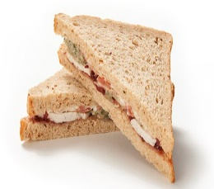 |  | 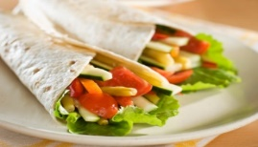 |  | 
 |  | Sandwich |  | Wrap |  | Pasta salad
 | 2 | 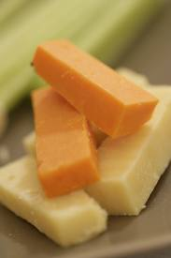 |  |  |  | 
 |  | Cheese |  | Yogurt |  | Egg
 | 3 |  |  | 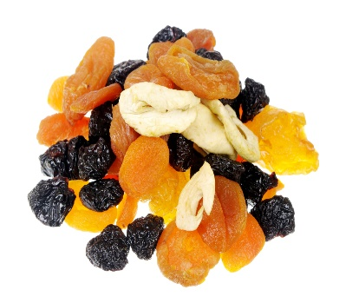 |  | 
 |  | Fresh fruit |  | Dried Fruit |  | Raw vegetables
 | 4 |  |  |  |  | 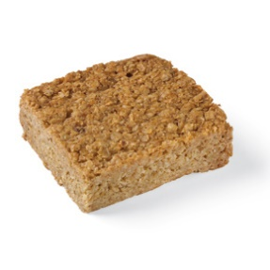
2x Biscuit |  |  | ½ packet crisps |  | Small flapjack or cake

A small flapjack
Reminder:
We are a healthy eating setting in line with Hampshire County Council’s schools. If your child is joining us for lunch, we do ask that the contents are healthy, nut free and of a suitable portion size for a pre-school child. These are a few suggestions, one item from each number is plenty and provides a healthy and balanced lunch for a typical 2–4-year-old.

Always include a bottle of water
Ensure the food is cold or able to remain warm and prepared in a way your child likes, i.e. crusts removed, slices instead of sticks
All children are encouraged to eat everything in their lunchbox so please try not over-load and 1 treat item is plenty.

Important Notice!
We are a nut free setting. Please can you check items do not contain any form of nuts before placing in lunch boxes!

