St Michaels Pre-school, Colebrook way Andover, SP10 3BB

T: 07940 569651

St Michael's Pre-school – Encouraging independence, resilience and learning through play (stmichaelspreschool.co.uk)

Spring 1 2024

Maintenance: 

• Remember we are a free-flow pre-school and children have access to outside provision in all weathers so with this in mind please ensure your children are dressed in appropriate clothing for the weather. We also enjoy lots of messy, exploration activities and water play with this in mind here is an essential kit list:  - A well-stocked bag with multiple changes of clothes including socks, t-shirts and jumpers as well as trousers and pants. Please remember a separate bag for wet/dirty clothes to be placed separate from clean clothes. Please remember to check and restock wipes and nappy sacks as well as nappies/pull ups daily.  - The weather has certainly taken a turn and our playroom can get a little chilly with children free flowing between the garden and the playroom therefore multiple layers are essential at this time of year.  - A warm coat is a must, as is a puddle suit or an extra waterproof coat and trousers and a pair of wellies and a change of shoes to be worn inside.  - Please remember to name all items if you don’t want them to become lost. |  | Key Dates:  Tuesday 2nd January- First day of term  Friday 9th February-Last day of term  Friday 8th March- Mother’s day breakfast  Saturday 23rd March- Teddy bears picnic  Friday 14th June- Father’s day breakfast  Saturday 29th June Games day and BBQ  Monday 22nd July-Leavers trip  
Important reminder- If your child was born between 1st September 2019 and 31st August 2020 you need to apply for their school place by online by the 15th January 2024. If you need any advice/help with applications please do come and speak to Naomi.
School admissions | Hampshire County Council (hants.gov.uk)

Gentle Reminder:
We are a healthy eating setting in line with Hampshire County Council’s schools. If your child is joining us for lunch, we do ask that the contents are healthy, nut free and of a suitable portion size for a pre-school child. Below are a few suggestions, one item from each number provides a healthy and balanced lunch for a typical 2-4 year old.
1 | 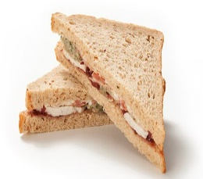 | 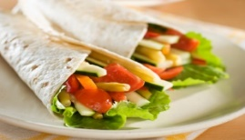 | 
 | Sandwich | Wrap | Pasta salad
2 | 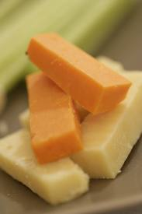 |  | 
 | Cheese | Yogurt | Egg
3 |  | 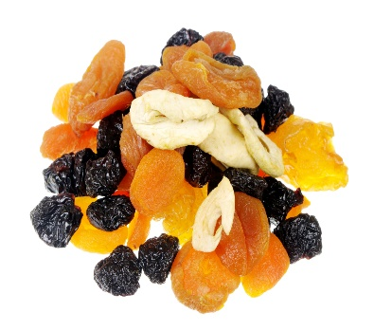 | 
 | Fresh fruit | Dried Fruit | Raw vegetables
4 |  | 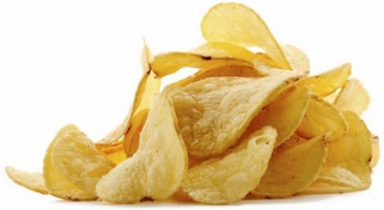 | 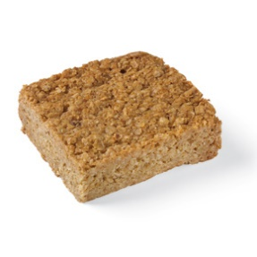
 | 2x Biscuit | ½ packet crisps | Small flapjack or cake
Always include a bottle of water
Ensure the food is cold or able to remain warm and prepared in a way your child likes, i.e. crusts removed, slices instead of sticks
All children are encouraged to eat everything in their lunchbox so please try not over-load and 1 treat item is plenty.

