At St Michaels Pre-school
• We are a free-flow pre-school and children have access to outside provision in all weathers so with this in mind please ensure your children are dressed in appropriate clothing for the weather. This includes bringing a warm waterproof coat every day. Winter isn’t quite over so ensuring your children come to pre-school layered up is highly advised. We also enjoy lots of messy, exploration activities and water play so changes of clothes and a bag for wet/dirty clothes are a must and puddle suits and wellies strongly advised. Please remember to check bags daily and restock nappies, wipes and nappy sacks.
• Naming all items is essential if you don’t want them to become lost. This includes bags and lunchboxes as it makes transitions such as lunchtime/home time easier.

St Michaels Pre-school
Colebrook way, Andover, SP10 3BB
T: 07940 569651
St Michael's Pre-school – Encouraging independence, resilience and learning through play (stmichaelspreschool.co.uk)
• Please continue to cut grapes, Olives and cocktail sausages length ways and pop an icepack inside your child’s lunchbox as we are unable to store them in a fridge.

Spring Term 2, February 2023
A reminder that our newsletter is emailed at the start of every half term so please make sure Naomi has your current email address. We would like the newsletter to be engaging as well as informative. Please do let us know if there is any information you think could be included in future? Don’t forget to also join our Facebook page to see regular updates on activities your children engage in and enjoy. And lastly a big warm welcome to all new families joining St Michaels this term. Parents and careers.

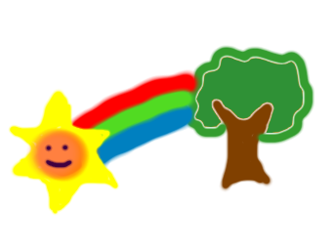

Key dates for your diary
Monday 20th February- Term begins
Friday 31st March-Last day of term
Friday 17th March-Mother’s day breakfast
Saturday 18th March- Teddy bears picnic
Friday 16th June- Father’s day breakfast
Friday 7th July-Leavers trip

Welcome and a big hello to Cody-Dax, Dhruv who joined us at the end of last term and Alfie, Leo and Winter-Rae who are joining us this term.

This half-term our topic is:
Our natural world, animals and habitats!

Each week we will learn about different animals and the environment they live in.

Week commencing the 20th Insects
Week commencing the 27th Jungle
Week commencing the 6th Forest
Week commencing the 13th Arctic
Week commencing the 20th Ocean
Week commencing the 27th Birds

World book day Thursday 2nd March
Every year here at St Michaels the staff enjoy dressing up as their favorite book characters and the children love working out who we are. It would be great if the children also dressed up as their favorite book characters too. As not all children are in on Thursday and we don’t want anyone to miss out on the fun we are going to celebrate world book day all week. Yes that’s right all week so your children can dress up any day or every day the week commencing 27th February.



Important Notice!
We are a nut free setting. Please can you check items do not contain any form of nuts before placing in lunch boxes!


